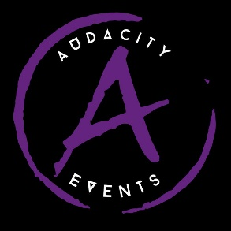 Audacity @ Drayton Manor Resort
Sunday 7th July 2024
Registration Form

Name:
Organisation Name (if applicable):
Address: Postcode:
Contact number:
Email:

Preferred Session: AM / PM (please delete)

Please enter details of all STREET TEAM entries and extend table as necessary:
Team name | Ability Category (Novice, Inters, SEN) | Age Group  (u4, u6 etc)

Please enter details of all CLASSICAL TEAM entries and extend table as necessary:
Team name | Ability Category (Novice, Inters, SEN) | Age Group  (u4, u6 etc) | Dance Style

Please enter details of all THEATRICAL TEAM entries and extend table as necessary:
Team name | Ability Category (Novice, Inters, SEN) | Age Group  (u4, u6 etc) | Dance Style

Please provide a list of all dancers competing in the event, their ages on the day of the event and the names of the teams that they are performing in (extend table where necessary):
DANCER NAME | DANCER AGE | TEAM(S)

I have read and understand the terms and conditions attached. I have written consent for all applicants entering the competition, allowing photographs and other media to be used as advertising purposes on social media and all other media in relation to the organisers of this event.
Any parents team participants must purchase a dancer ticket.

Signed: ……………………………………………………………………………….Date:

I require:
Ticket/Entry Type | Amount Required | Total Cost
Toddler Competitor Ticket + park admission @ £28 |  | £
4yrs+ Competitor Ticket + park admission @ £44 |  | £
Toddler Spectator Ticket + park admission @ £25 |  | £
4yrs+ Spectator Ticket + park admission @ £41
Competition only Dancer Ticket @ £16 |  | £
Competition only Spectator Ticket @ £13 |  | £
Additional Entries @ £5 per dancer |  | £
U2 Tickets + park admission @ £0 |  | £0
Carer Competition only tickets @ £0 |  | £0
Park only ticket for coaches @ £28 (max of 2) |  | £
 | Grand Total = | £

Grand total = £
Please forward completed entry forms to: info@audacityevents.co.uk

